Experimental
The objective of our experiments was to present and analyze rheological differences and similarities between various types powders mainly of biological origin (foods, biofuels) as affected by moisture content.
The annular shear cell-type powder rheometer used in our lab is similar to that described by Klausner [1]. A simplified sketch of the rheometer is shown in Fig. 1.
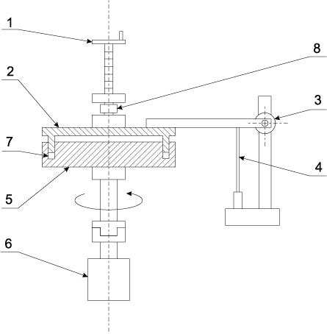
Fig. 1. Simplified sketch of the annular rheometr. 1- shear plate positioner, 2-shear plate, 3-tangential load transducer, 4-displacement transducer, 5-rotating cell, 6-driving geared motor, 7-annular space, 8- normal load transducer

The powder sample is sheared in the annular space between the upper shear plate and the bottom rotating cell. The space has external and internal diameters of 102 and 88 mm, respectively, and a depth of 9 mm. The upper shear plate is fixed by a moment arm and the bottom cell is driven by a geared motor with an adjustable rotational speed in the range of 5-300 rpm. Both upper and bottom parts of the rheometer are made of hardened and polished steel. To avoid escaping the powder out of the annular space during experiments a flat ring seal is fixed to a groove in the upper plate being the working shearing surface.
Two force transducers, both with range of 200 N and an accuracy class of 0.5 (what means 1 N for this measurement range) are used to measure the tangential force resulting from powder shearing and normal force resulting from powder compression and dilation, respectively. The current position of the upper plate was adjusted with the upper plate positioner and measured with a displacement transducer. The unique feature of this rheometer design is the possibility to settle precisely the height of the powder layer under examination and to ensure that the height corresponds to the shear band thickness, i.e. about 15 – 20 particle diameters [1].
The powder sample of mass, m, required to achieve the desired powder bed height is evenly deposited in the annular rheometer space and the shear plate was established in a position to obtain an appropriate powder compaction. The lower plate speed was than adjusted to a definite values (with lowest achievable steady value of 5 rpm) and it was allowed to rotate until the normal and shear stresses reached a constant values. The measured data of loads, F_{n} and F_{t} , bed height, δ, and rotational speed, n, were recorded. After the measurements were accomplished, the shear plate was moved up until it was no longer in contact with the powder in the rheometer annular space. The plate was than rotated again with the same speed repeated and the loads, f_{n} and f_{t} , resulting from friction of polyethylene seal against the plate wall were recorded.
The treatment of the data collected depended on whether the load cell was in tension or compression and it was the same as given in Klausner [1]

- normal stress for load cell in compression
$σ_{n}=\frac{W+F_{n}-f_{n}}{π\left(R_{o}^{2}-R_{i}^{2}\right)}$ (1)
and in tension
$σ_{n}=\frac{W-F_{n}-f_{n}}{π\left(R_{o}^{2}-R_{i}^{2}\right)}$ (2)
where W = 15,83 N is the weight of the upper shear plate, R_{o}= 51 mm is the outer annular radius, and R_{i} = 44 mm is the inner annular radius. F_{n} and f_{n} are the measured normal loads at working and tare conditions respectively.
- mean shear stress
$τ=\frac{3\left(F_{t}-f_{t}\right)L}{2π\left(R_{o}^{3}-R_{i}^{3}\right)}$ (3)
where F_{t} and f_{t} are the measured tangential loads at working and tare conditions respectively, L = 175 mm is the moment arm length.
- shear rate
$\dot{γ}=\frac{u}{δ}=\frac{π∙d∙n}{δ}$ (4)
where δ is powder bed height in the annular gap, d = 95 mm is the mean value of annular gap diameter and n is the rotational speed.

General goal of research
Since the examined materials are of biological origin our aim is to confirm that the effect of water adsorption is manifested not only in modification of a powder bed strength due to liquid bridging. We expect that the presence of water brings about changes in the size and shape of particles by swelling as well as alteration in material strength properties (Poisson ratio, shear modulus, density) as well as in contact features (restitution coefficient, friction coefficients) due to soaking.

Experimental examples
We have already collected a set of experimental data for different material types including industrial (glass beds, cellulose, PVC etc.), food (semolina, starch, powdered milk etc.) and biofuel (lignite, oak chips, pine chips etc.) powders.

a)
b)
c)
Fig. 2. Example of experimental results for 0.25-05 mm glass beads
a)
b)
c)
Fig. 3. Example of experimental results for powdered milk 75-250 μm

Actually, there is no general trend regarding the effect of moisture content on the recorded powder bed properties, however the powder behaviour is different versus rotation speed and humidity. Therefore our first idea is the effect of moisture on the powder through the previously mentioned mechanisms that can cause reinforcement (superposition) and/or damping (suppression) of different actions.

Approach to DEM modeling

Since the geometry of the annular rheometer (Fig. 4) and the size of studied particles can cause extremely large simulation times our first approach was to use only a section of the apparatus (Fig. 5) with periodic boundaries concept and moving plane contact model applied.
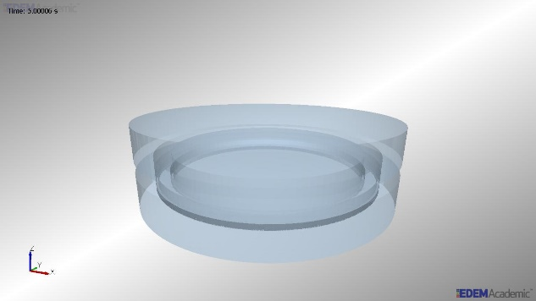 | 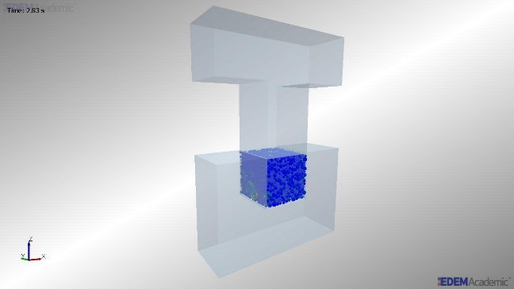
Fig. 4 Screenshot of annular rheometer | Fig. 5 Screenshot of 1/60 section
However, such approach requires a validation to confirm that the results obtained for a section can be transferred to a whole rheometer case. In our opinion the best testing material for validation is glass beds. We have prepared initial EDEM (2.7 Academic) files for rheometer and its 1/60 section rotating at 5 and 25 rpm (4 cases) with detailed parameters listed in Table 1. Additionally, to ensure constant normal load the simulation should be stopped after about 5 seconds (to settle the particles) and a servo file should be executed (with coupling sever started) for further shearing simulation.

Table1. Selected parameters of rheometer simulation
 | Rheometer |  | 1/60 section of rheometer
File name | Rheometer05 | Rheometer25 | Section05 | Section25
Glass properties (powder):
- Poisson ratio | 0.2
- Shear modulus [Pa] | 2.62e10
- Density [kg/m³] | 2500
Steel properties (geometry)
- Poisson ratio | 0.3
- Shear modulus [Pa] | 8e10
- Density [kg/m³] | 8000
Particle to particle contact model | Hertz-Mindlin with RVD rolling friction
Particle to geometry contact model | Hertz-Mindlin with RVD rolling friction |  | Moving plane + Hertz-Mindlin with RVD rolling friction
Glass – glass interactions
Coefficient of restitution | 0.7
Coefficient of static friction | 0.5
Coefficient of rolling friction | 0.05
Glass – steel interactions
Coefficient of restitution | 0.7
Coefficient of static friction | 0.1
Coefficient of rolling friction | 0.01
Particle radius [m] | 1.875e-4
Number of particles | 300 000 |  | 4 200
Particle size distribution | Normal with StD 0.05 by radius
Normal load [kPa] | 8
Apparent mass of top plate [kg] | 1.216926818 |  | 0.020282114
Simulation time [s] | 60
Fixed timestep | 25% of Rayleigh timestep
Cell size | 3 x Rmin
Bottom plate rotation speed [rpm] | 5 | 25 | 5 | 25
Bottom plate rotation speed [rad/s] | 0.5235988 | 2.617994 | - | -
Bottom plate apparent linear (peripheral) speed [m/s] | - | - | 0.0248709 | 0.124355

Literature
[1] Klausner, J.F., Chen, D., & Mei, R., (2000). Experimental investigation of cohesive powder rheology. Powder Technology, 112, 94-101.

